* Joins Query – 1
* Create following Tables: cust_mstr(cust_no,fname,lname) add_dets(code_no,add1,add2,state,city,pincode). Retrieve the address of customer Fname as ‘xyz’; and Lname as ‘pqr’.

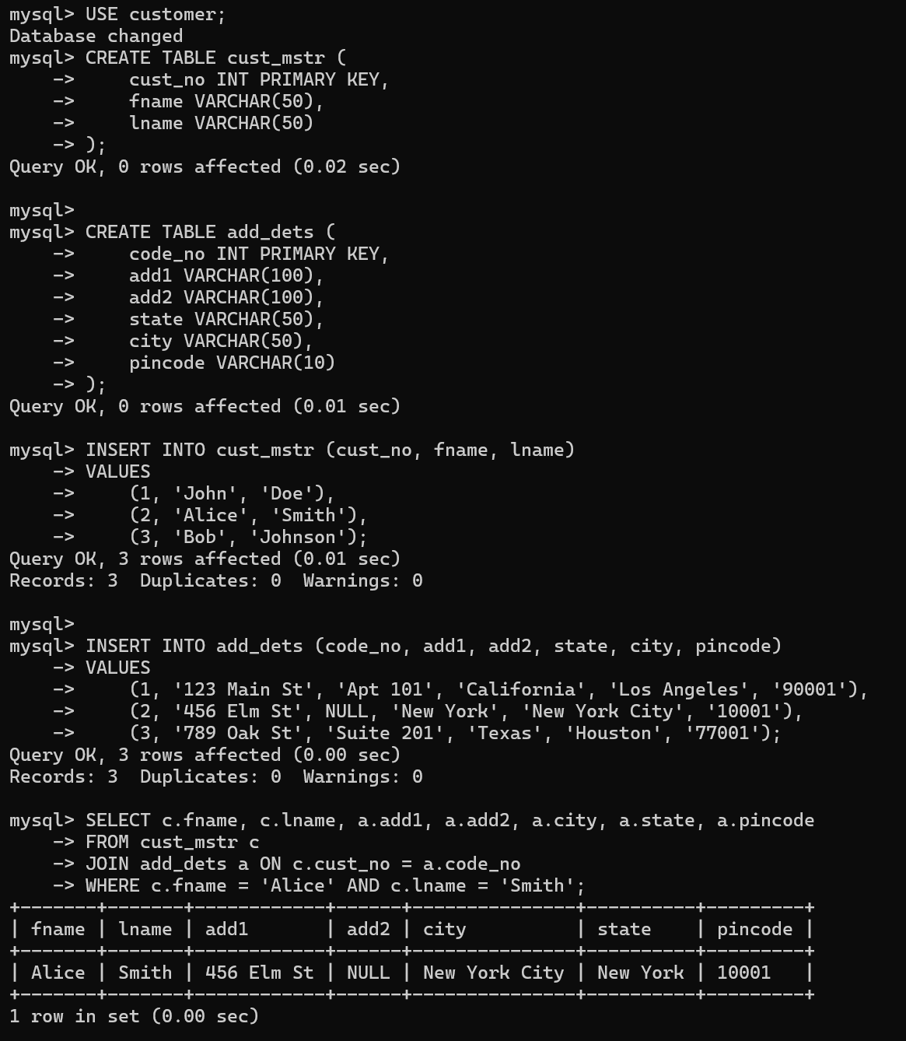

* Joins Query – 2
* Create following Tables:

cust_mstr(custno,fname,lname),

acc_fd_cust_dets(codeno,acc_fd_no),

fd_dets(fd_sr_no,amt).

List the customer holding fixed deposit of amount more than 5000

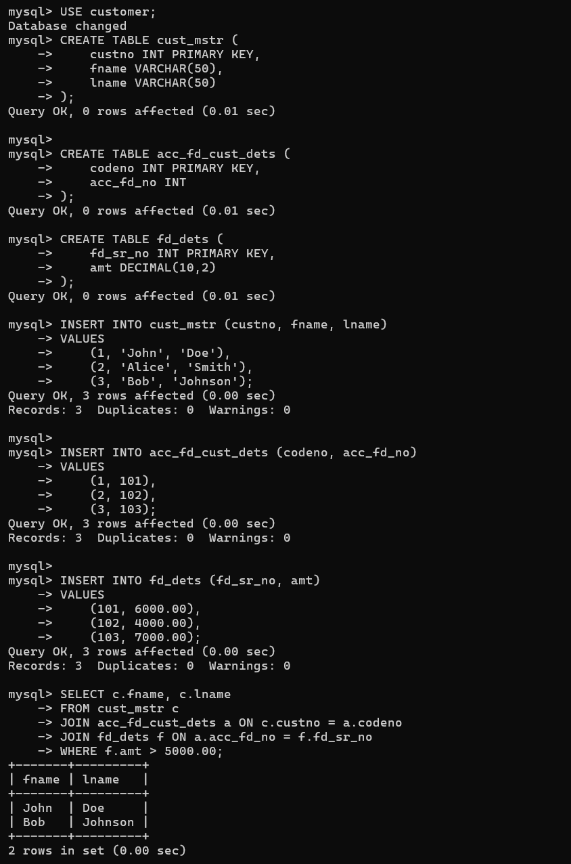

* Joins Query – 3
* Create following Tables:

emp_mstr(e_mpno,f_name,l_name,m_name,dept,desg,branch_no), branch_mstr(name,b_no).

List the employee details along with branch names to which they belong.

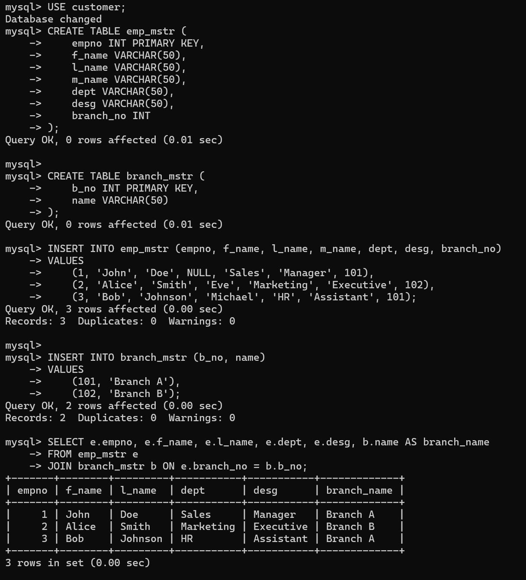

* Joins Query – 4
* Create following Tables:

emp_mstr(emp_no,f_name,l_name,m_name,dept),

cntc_dets(code_no,cntc_type,cntc_data)

List the employee details along with contact details using left outer join & right join.

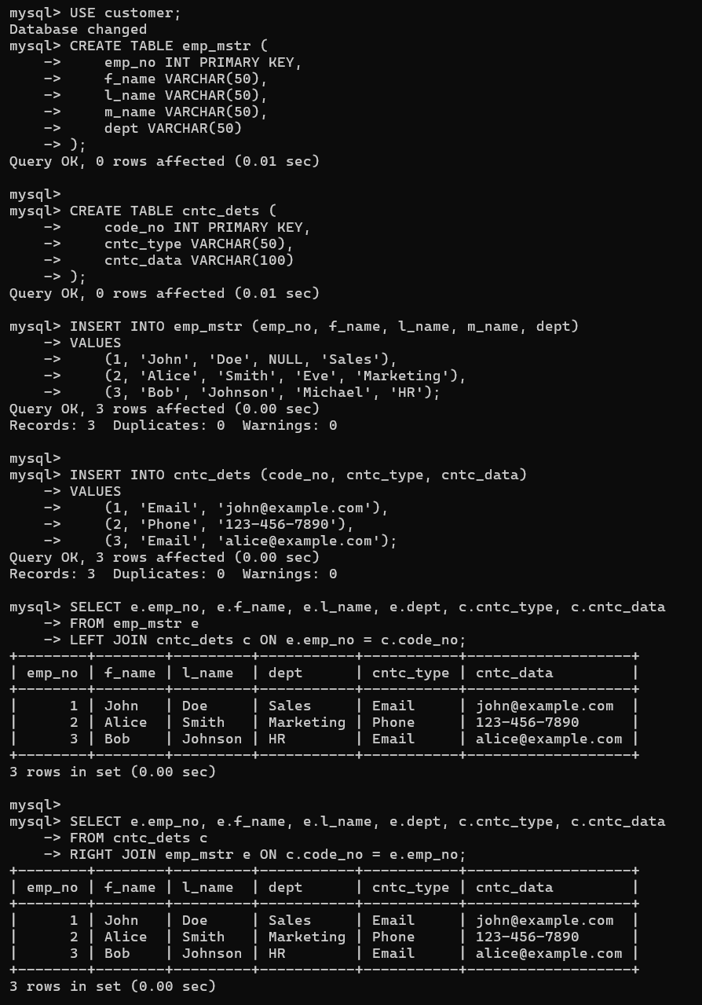

* Joins Query – 5
* Create following Tables:

cust_mstr(cust_no,fname,lname),

add_dets(code_no,pincode).

List the customer who does not have bank branches in their vicinity.

